Comparison of different datasets for 2017

Type of injury | Year | Quoted value | Our value | Known reason if different? | Source | Website
Transport | 2017 | N/A | 42,158 | CDC report for 2017 does not have comparable value, so compared motor vehicle | CDC | https://www.cdc.gov/nchs/fastats/accidental-injury.htm  https://www.cdc.gov/nchs/data/nvsr/nvsr68/nvsr68_09-508.pdf (pg. 35-36)
Motor vehicle | 2017 | 40,231 | 39,707 (road traffic) | CDC quote is for motor vehicles (road and off-road). Ours is for road traffic. Therefore, CDC also included V82.0–V82.1, V83–V86, V87.0–V87.8, V88.0–V88.8, V89.0, V89.2 | CDC
Falls | 2017 | 36,338 | 36,338 |  | CDC
Drownings | 2017 | 3,709 | 3,709 |  | CDC
Suicide | 2017 | 47,173 | 47,103 | CDC additionally includes U03 and Y87.0 (not officially in ICD10) | CDC
Assault | 2017 | 19,510 | 19,278 | CDC additionally includes U01, U02 and Y87.1 (not officially in ICD10) | CDC

Comparison of different datasets for 1999-2016

Type of injury | Year | Quoted value | Our value | Known reason if different? | Source | Website
Transport | 1999-2016 | 772,138 | 771,852 |  | NCHS (from CDC Wonder) | https://healthdata.gov/dataset/nchs-injury-mortality-united-states
Falls | 1999-2016 | 418,177 | 418,140 |  | NCHS (from CDC Wonder)
Drownings | 1999-2016 | 63,096 | 62,880 |  | NCHS (from CDC Wonder)
Suicide | 1999-2016 | 649,843 | 648,444 | CDC additionally includes U03 and Y87.0 (not officially in ICD10) | NCHS (from CDC Wonder)
Assault | 1999-2016 | 314,705 | 307,246 | CDC additionally includes U01, U02 and Y87.1 (not officially in ICD10) | NCHS (from CDC Wonder)

Comparison of main model with one with absolute temperature values

Main model

$$\log\left({death rate}_{state-time}\right)= \\ α_{0} + β_{0}·time+ \\ α_{state} + β_{state}·time+ \\ α_{month} + β_{month}·time+ \\ ζ_{state-month}+ \\ ψ_{state-month} .time+ \\ ν_{time} + \\ γ_{month}·{Anomaly}_{state-time}+ \\ ɛ_{state-time}+$$

Model with absolute temperature

$$\log\left({death rate}_{state-time}\right)= \\ α_{0} + β_{0}·time+ \\ α_{state} + β_{state}·time+ \\ α_{month} + β_{month}·time+ \\ ζ_{state-month}+ \\ ψ_{state-month} .time+ \\ ν_{time} + \\ γ_{month}·{Anomaly}_{state-time}+ \\ δ_{month}·{Norm temperature}_{state-month}+ \\ ɛ_{state-time}+$$

$$γ_{month}·{Anomaly}_{state-time}+$$
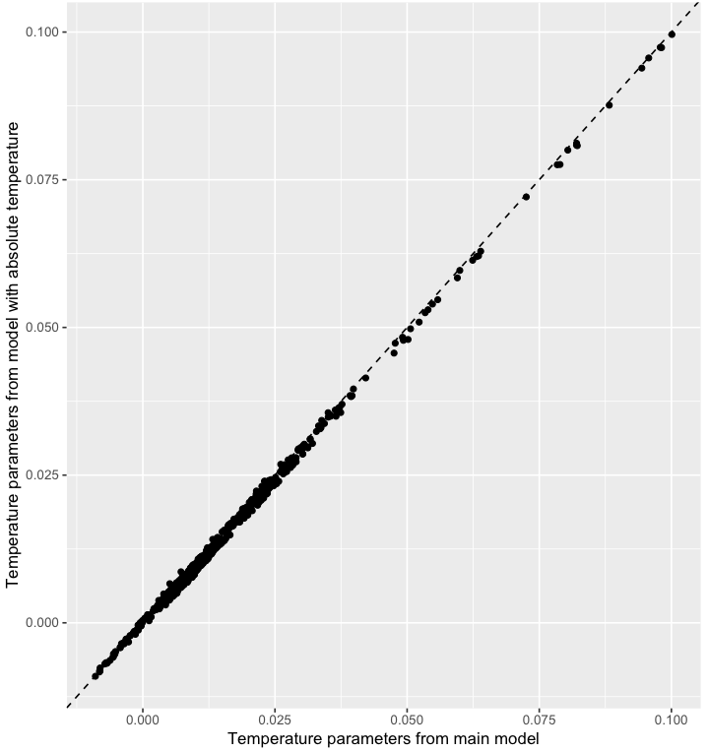

$$α_{0}$$
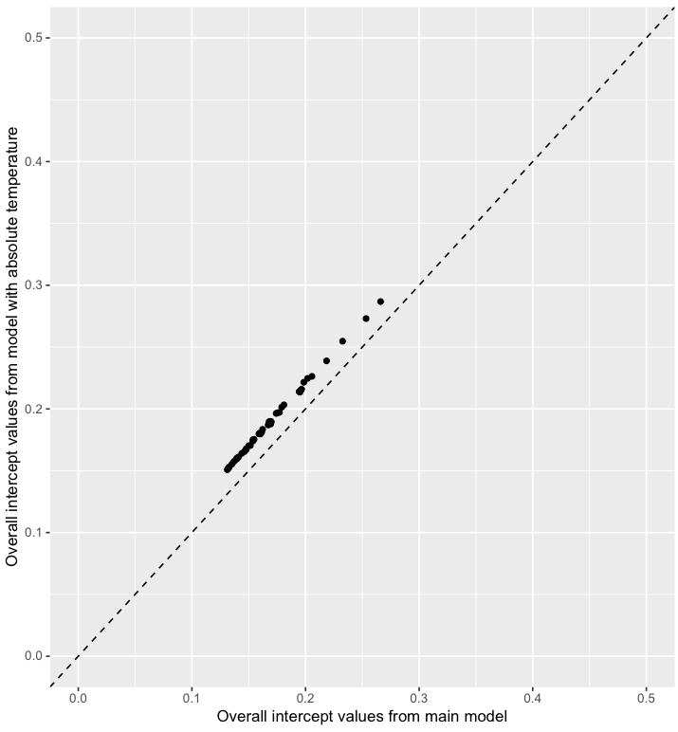
$δ_{month}·{Norm temperature}_{state-month}+$